Survey Report

Project Title
SmartSpend AI – A Personal Expense Management Application

Team Members
No. | Full Name | Student ID | Role
1 | Tạ Bỉnh Phong | 24127100 | Leader
2 | Phan Văn Bá Đạt | 24127023 | Member
3 | Nguyễn Trịnh Tuấn Văn | 24127144 | Member
4 | Nguyễn Trần Lan Viên | 24127268 | Member

Survey of user demand for SmartSpend AI personal expense management app
Survey Date: June 11, 2026 - June 15, 2026
Number of Participants: 7 people

1. OVERVIEW

1.1. Survey Objective
- Identify user habits, needs, and pain points in personal expense management.
- Evaluate the perceived usefulness of AI-supported features such as receipt scanning, transfer-image reading, automatic categorization, budget alerts, and spending reports.
- Understand privacy concerns, trust requirements, willingness to try, and willingness to pay for SmartSpend AI.
- Collect user suggestions to guide feature prioritization for the SmartSpend AI project.

1.2. Survey Methodology
- Format: Online survey using a Google Form-style questionnaire.
- Target User: Young users, mainly students and early-career workers aged 18 to 27.
- Sample Size: 7 valid responses. Because the sample is small, the findings should be treated as preliminary user discovery rather than statistically representative market research.

2. INFORMATION GAIN

2.1. Respondent profile
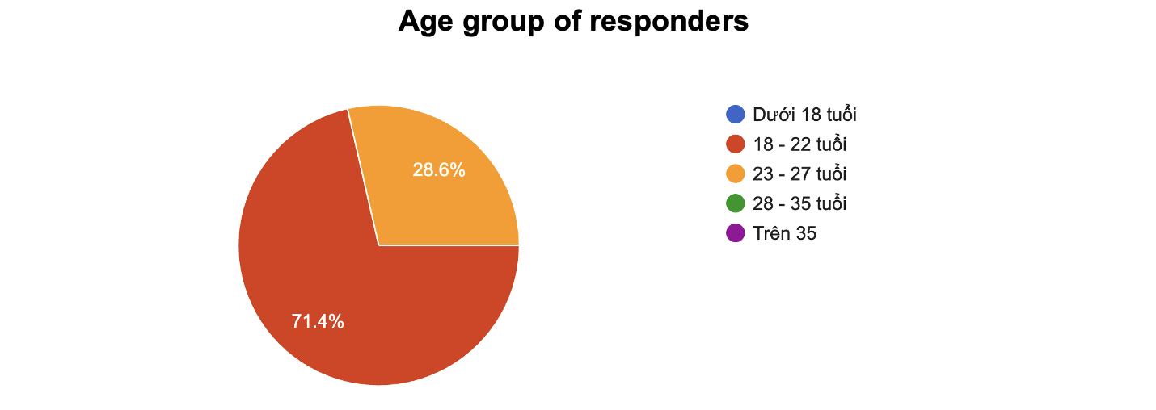
Figure 1. Age distribution of respondents
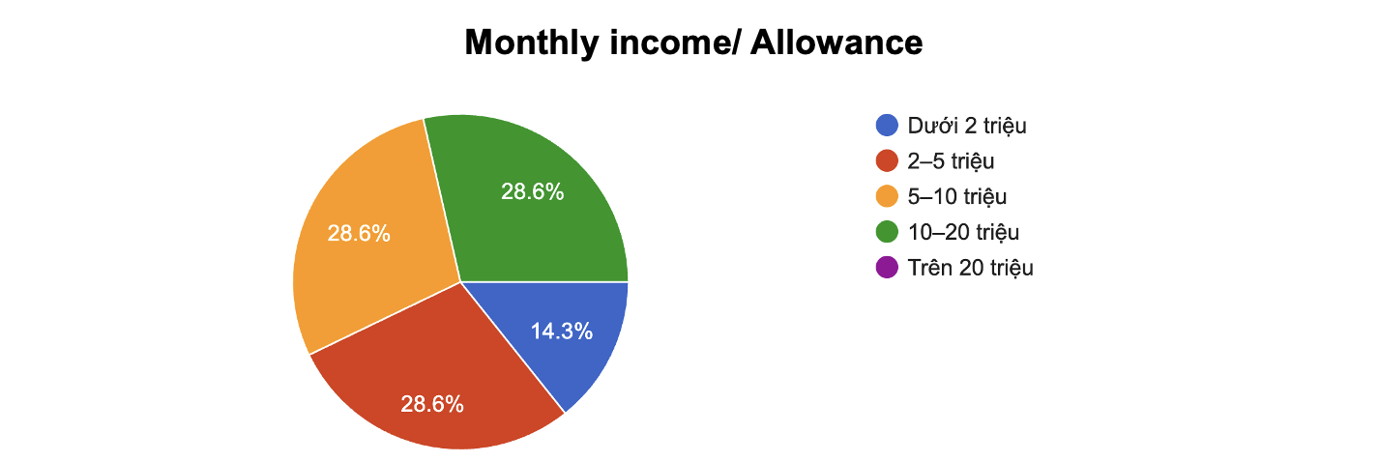
Figure 2. Monthly income/allowance distribution
Comment:
The survey mainly reached young users: 5 out of 7 respondents are aged 18-22, and 2 out of 7 are aged 23-27. Most respondents are students, while the remaining respondents include one IT worker and one office employee. Their monthly income or allowance is spread across below 2 million VND, 2-5 million VND, 5-10 million VND, and 10-20 million VND. This profile is suitable for the SmartSpend AI concept because young users often have frequent small transactions, limited budgets, and a need to understand where their money goes.

2.2. Spending behavior and current tracking habits
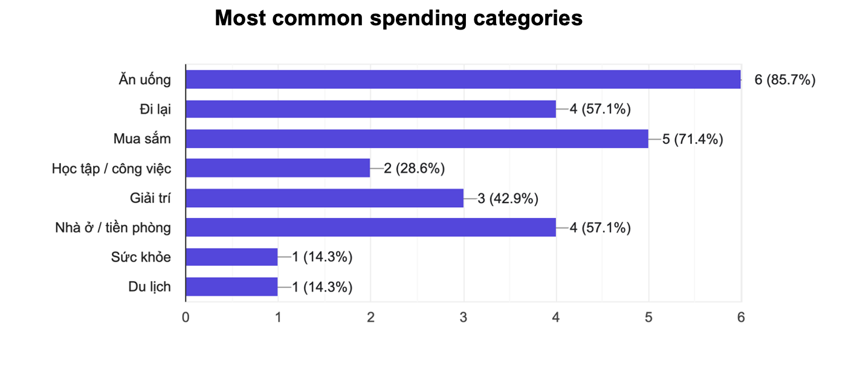
Figure 3. Categories where respondents spend the most

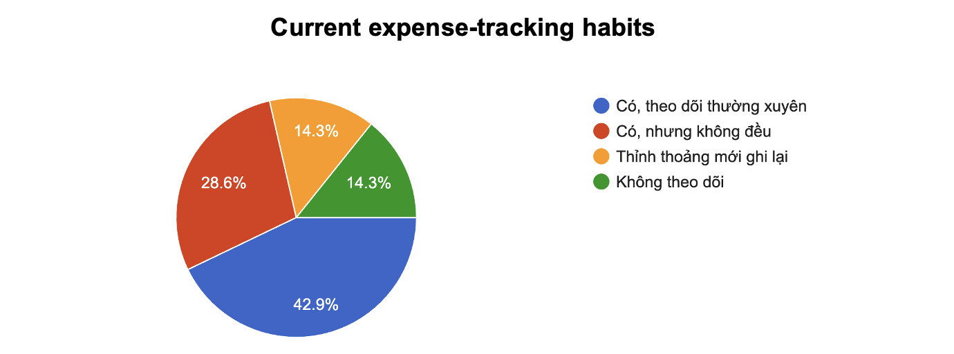
Figure 4. Current expense-tracking habits
Comment:
Food is the most common spending category, selected by 6 out of 7 respondents, followed by shopping, transportation, and rent/room expenses. Regarding current tracking behavior, only 3 respondents track expenses regularly, while others track irregularly, occasionally, or do not track at all. Most respondents who track expenses rely on bank or e-wallet transaction history rather than a dedicated expense-management app. This indicates a clear opportunity for SmartSpend AI to convert existing passive checking behavior into structured and useful expense records.

2.3. Difficulties in manual expense management

Reasons users give up recording expenses
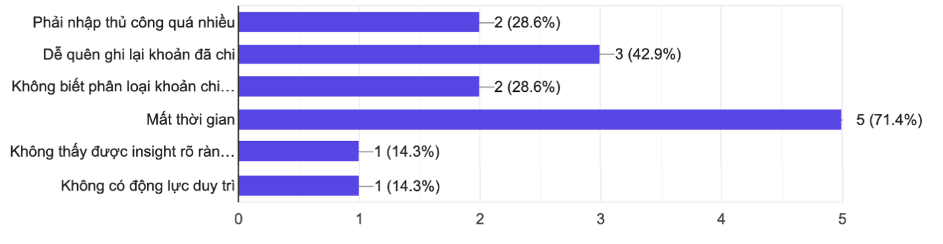
Figure 5. Reasons respondents feel annoyed or give up when recording expenses
Comment:
The main barriers are time consumption, forgetting to record transactions, too much manual input, and difficulty categorizing expenses. The average difficulty rating for self-managing expenses is 4.1/5, and 5 out of 7 respondents rated the difficulty at 4 or 5. Four respondents said they very frequently forget to record expenses, especially small transfers. These findings support the need for automation, reminders, and automatic categorization in SmartSpend AI.

2.4. AI-supported features and feature priority
Features users are interested in
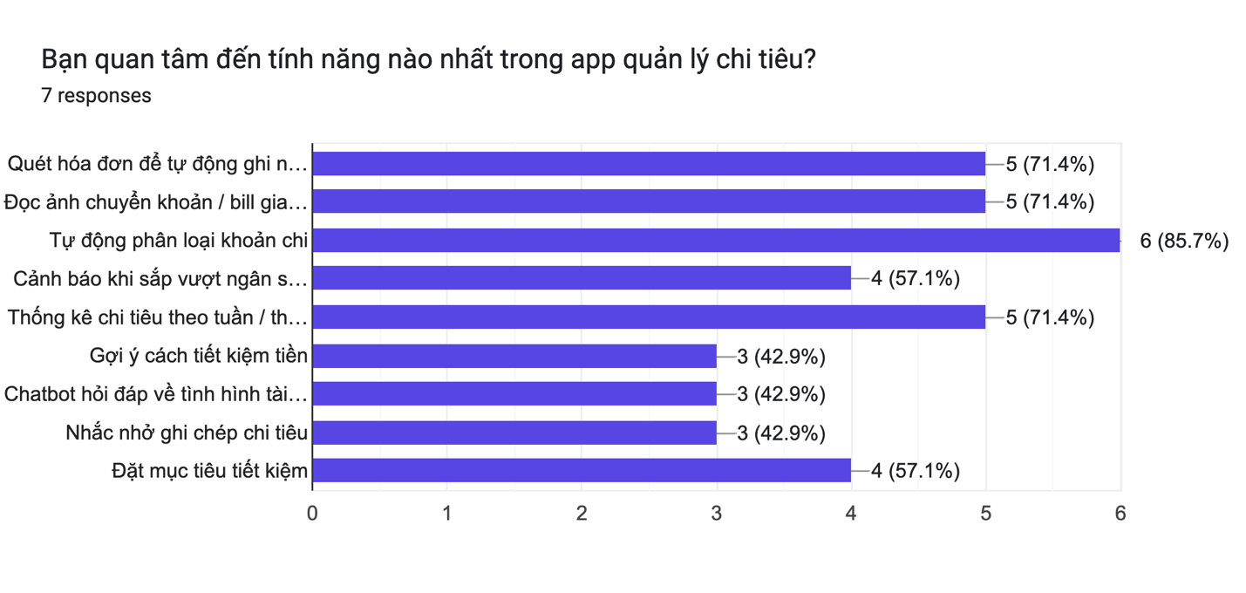
Figure 6. Features respondents are interested in

Most prioritized features
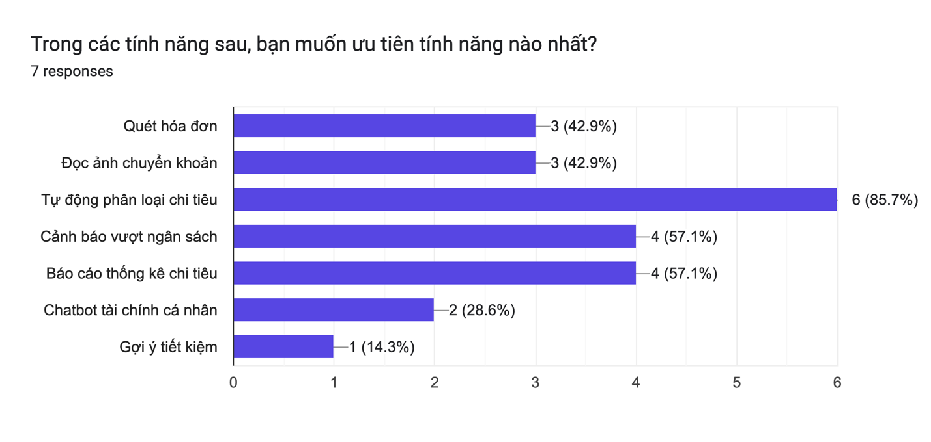
Figure 7. Features respondents want to prioritize
Comment:
The most requested features are automatic expense categorization, receipt scanning, transfer/bill image reading, weekly/monthly spending reports, budget alerts, and saving goals. When forced to prioritize, automatic categorization appears as the strongest feature, selected by 6 out of 7 respondents. This suggests that SmartSpend AI should focus first on reducing manual work before adding more advanced advisory features.

2.5. Privacy concerns and trust requirements
Factors that increase trust
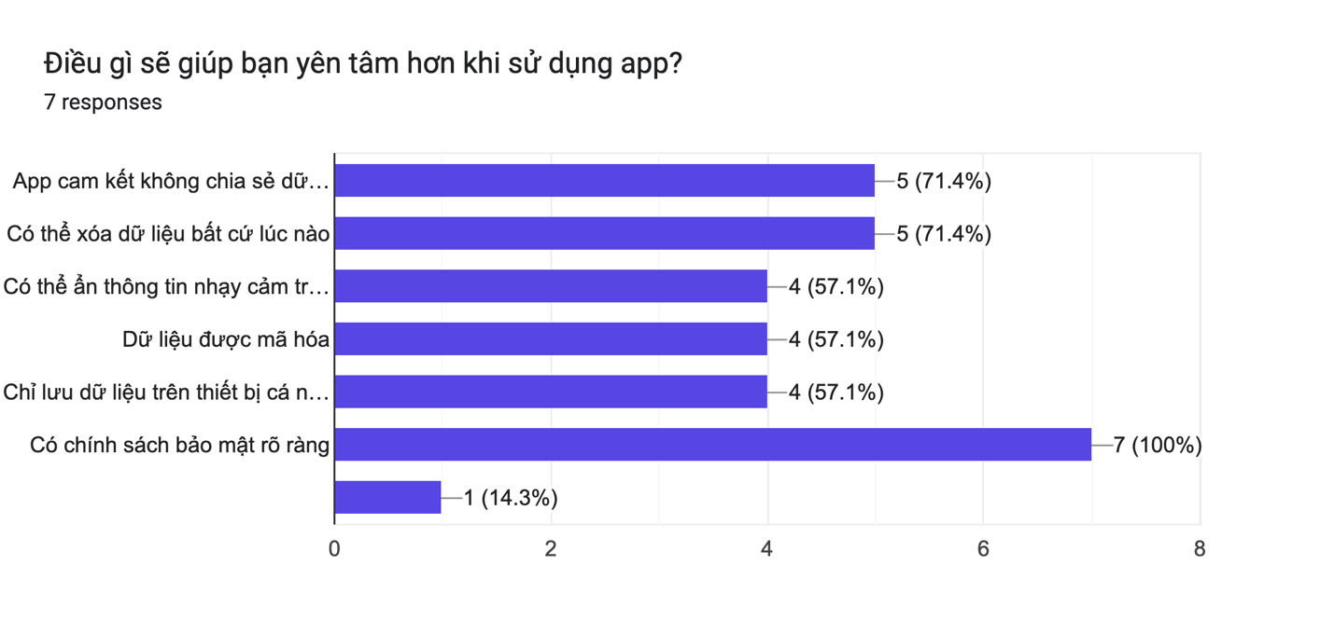
Figure 8. Factors that would make users feel safer
Comment:
Privacy is a major adoption factor because SmartSpend AI may process receipts, transfer images, and transaction-related information. Every respondent selected a clear privacy policy as a trust requirement. Other important trust factors include a commitment not to share personal data, the ability to delete data at any time, hiding sensitive information, encryption, and local-device storage. Therefore, privacy and transparency should be treated as core product requirements rather than optional supporting features.

2.6. Difficulties and expectations from open-ended responses
Category | Typical Raw Responses | Translated Responses
Forgetting small expenses | “Rất thường xuyên”; “Chuyển khoản nhỏ”; “Ăn uống hằng ngày” | “Very frequently”; “Small transfers”; “Daily food expenses”
Manual input takes time | “Tốn thời gian”; “Mất thời gian”; “Phải nhập thủ công quá nhiều” | “Time-consuming”; “Takes time”; “Too much manual input”
Categorization difficulty | “Không biết phân loại khoản chi như thế nào” | “Do not know how to categorize expenses”
App switching inconvenience | “Việc phải mở qua lại giữa 2 app ngân hàng, ví điện tử với app ghi chép chi tiêu cá nhân” | “Having to switch back and forth between banking/e-wallet apps and the expense-recording app”
Need for bank/payment integration | “Liên kết với ngân hàng, thanh toán - chi tiêu trực tiếp” | “Connect with banks and payment/expense flows directly”

Comment:
Open-ended responses reinforce the quantitative findings. Users do not only want a place to store expenses; they want the app to reduce friction in the recording process. Several respondents specifically mentioned small transfers, daily food expenses, and app switching as situations where they forget or feel unwilling to record expenses. This supports SmartSpend AI’s focus on automatic data capture from receipts, transaction images, and potentially bank/e-wallet integrations in future versions.

2.7. Expected features
Category | Typical Raw Responses | Translated Responses
Automation | “Yêu cầu nhập loại chi phí sau khi chuyển khoản”; “Sao cho người dùng không quên nhập khoản chi vào app” | “Ask for expense type after transfer”; “Make sure users do not forget to enter expenses into the app”
Bank/payment connection | “Liên kết với ngân hàng, thanh toán - chi tiêu trực tiếp” | “Connect with banks, payment, and expense flows directly”
Usability | “Dễ sử dụng, thao tác nhanh chóng”; “Nhanh gọn, tiện lợi”; “Giao diện thuận lợi, chức năng dễ dùng” | “Easy to use, fast operations”; “Quick and convenient”; “Convenient interface and easy-to-use features”
Cost sensitivity | “Không tốn phí”; “Chỉ dùng nếu miễn phí” | “No cost”; “Only use if it is free”

Comment:
Users expect SmartSpend AI to be simple, fast, and low-effort. The strongest expectation is not a large number of complex features, but a smooth core flow that helps users remember and categorize expenses automatically. Cost sensitivity is also clear, especially among students, so the product should prove value through a free core experience before asking users to pay.

3. CONCLUSION FOR SMARTSPEND AI
Based on the survey findings, SmartSpend AI should focus on solving the most painful part of personal expense management: users forget to record expenses, feel manual input is time-consuming, and often do not know how to categorize spending. The survey shows strong interest in AI-supported automation, especially automatic categorization, receipt scanning, transfer/bill image reading, budget alerts, and spending reports. At the same time, privacy and trust must be designed into the product from the beginning because users are cautious about allowing an app to read financial-related images or transaction data.
For the first version, SmartSpend AI should prioritize a simple and reliable expense-recording flow. The product should allow users to quickly capture a bill or transfer screenshot, automatically detect key information, suggest a category, and generate weekly/monthly reports. Budget alerts and saving goals should be included as supportive features to help users control spending. Chatbot-style financial advice can be added later after the app has enough accurate spending data and users have built trust in the system.
SmartSpend AI should begin with a free or freemium model. The free version can include core tracking, automatic categorization, and basic reports. This approach allows the product to attract users first, build habit and trust, and then introduce monetization only when users clearly experience the value.
SmartSpend AI will focus on features that meet end-users’ needs:
Feature | Priority | Reason
Automatic expense categorization | High | Most prioritized feature; directly reduces manual effort and categorization confusion.
Receipt scanning and transfer/bill image reading | High | Strongly rated as useful; helps users record expenses when they forget manual input.
Weekly/monthly spending reports | High | Helps users understand where their money goes and identify spending patterns.
Budget alerts | High | Supports users who often exceed budget or spend more than planned.
Privacy controls and transparent policy | High | Essential for adoption because financial images and transaction data are sensitive.
Saving goals and saving suggestions | Medium | Useful for motivation after the core tracking flow is stable.
Chatbot financial assistant | Medium | Potential differentiator, but should be introduced after enough reliable data is available.
Bank/e-wallet integration | Future enhancement | Highly valuable but may require technical, legal, and security preparation.

